**Technical Architecture**

The technical architecture diagram illustrates the various components and technologies involved in the Mushroom Species Classification AI Project. It showcases the high-level structure and interactions between different elements of the system. Please note that this is a conceptual diagram and specific technologies and configurations may vary based on project requirements.

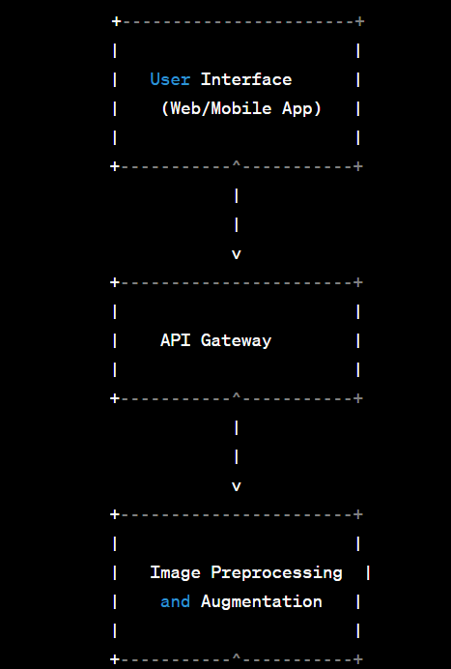

Key Components:

1. User Interface:

* Provides a user-friendly interface for users to interact with the system, including uploading mushroom images and viewing classification results.

1. API Gateway:

* Acts as a central entry point for all API requests, facilitating communication between the user interface, image preprocessing, classification engine, and database components.

1. Image Preprocessing and Augmentation:

* Performs preprocessing techniques such as resizing, normalization, and noise reduction on the uploaded mushroom images.
* Applies augmentation methods to increase dataset variability and improve model performance.

1. Convolutional Neural Network (CNN) Model:

* Utilizes deep learning techniques, specifically CNNs, to classify mushroom species based on their visual characteristics.
* The model can be trained using transfer learning with pre-trained models such as VGG16, ResNet, or Inception, and fine-tuned with the mushroom dataset.

1. Mushroom Species Classification Engine:

* Executes the trained CNN model to classify mushroom species based on the preprocessed images.
* Provides the classification results to the user interface for display and additional information retrieval.

1. Mushroom Species Information Database:

* Stores comprehensive information about different mushroom species, including habitat, edibility, medicinal properties, and visual characteristics.
* Enables quick retrieval of species information based on the classification results.

Please note that the technical architecture diagram provides an overview of the system's components and their interactions. It can be further extended and detailed based on specific implementation requirements and considerations.

**Open Source Frameworks**

1. TensorFlow:

* TensorFlow is a popular open-source deep learning framework developed by Google.
* It provides a comprehensive ecosystem for building and training machine learning models, including neural networks.
* TensorFlow offers extensive support for image classification tasks, making it suitable for implementing the mushroom species classification model.

1. PyTorch:

* PyTorch is an open-source deep learning framework that has gained significant popularity in the research community.
* It provides dynamic computational graphs, allowing for more flexible model architectures and easier debugging.
* PyTorch offers a user-friendly API and excellent support for training convolutional neural networks (CNNs), making it suitable for the mushroom species classification task.

1. Keras:

* Keras is a high-level neural networks API written in Python and is compatible with both TensorFlow and Theano.
* It offers a simple and intuitive interface for designing and training deep learning models, including CNNs.
* Keras provides a wide range of pre-trained models, making it convenient for rapid prototyping and transfer learning in the mushroom species classification project.

1. scikit-learn:

* scikit-learn is a powerful open-source machine learning library for Python.
* It provides a variety of machine learning algorithms and tools for data preprocessing, feature selection, and model evaluation.
* scikit-learn can be used in conjunction with other frameworks to handle data preprocessing tasks or for implementing complementary machine learning algorithms alongside the CNN model.

1. OpenCV:

* OpenCV (Open Source Computer Vision Library) is an open-source computer vision and image processing library.
* It provides various image processing and computer vision algorithms, such as image resizing, color conversion, and feature extraction.
* OpenCV can be used for image preprocessing and augmentation tasks in the mushroom species classification project.

By incorporating these open-source frameworks into the project, developers can benefit from their extensive functionality, community support, and active development. It is important to consider the specific requirements and compatibility of the frameworks with the project's overall design and architecture.